[The US wants to fix its broken lithium battery supply chain - The Verge](https://www.theverge.com/2021/6/8/22524663/us-lithium-battery-supply-chain-broken)

Plans to improve the EV battery supply chain in North America:

The first step would be to build out a domestic supply chain for Lithium-ion EV batteries in North America. The goal would be to do everything, from the mining of raw materials to manufacturing EV batteries (including recycling the batteries).

USA Department of Energy’s blueprint/vision/plan for the future: [National Blueprint for Lithium Batteries](https://www.energy.gov/eere/vehicles/articles/national-blueprint-lithium-batteries)

[| Department of Energy](https://www.energy.gov/eere/vehicles/articles/national-blueprint-lithium-batteries)

Cobalt is the most expensive material in an EV battery. Cobalt-free is a promise by Tesla along with CATL.

Let us look at the Lithium solution for North America. The USA holds an estimated 3.6% (750,000 tonnes) of the world’s Lithium deposits and Canada 2.6% (530,000 tonnes). This amounts to a total of 6.2% of the lithium deposits in North America [1][2].

There are two possible locations for large-scale mining operations to take place in the USA, they are the Silver Peak Lithium Mine which is located in Clayton Valley, Nevada, is currently operational and under Albemarle Corporation producing 5000 Metric tonnes of Lithium Carbonate Equivalent (LCE). Albemarle’s Chile operation — in the Salar de Atacama region — has the capacity to produce 85,000 metric tons per year. The operation there uses the same brine production process that was first developed in Nevada.

Albemarle is also increasing its footprint at Silver Peak. In January 2021 the company announced plans to double capacity to 10,000 metric tons a year, which the company said is enough to power around 160,000 electric vehicles.

**Support from the Government**

While the vast majority of battery production takes place outside the U.S. — China is a key player, currently refining 56.5% of global lithium, according to Benchmark — the Biden administration is trying to change that.

In February, the White House announced funding for the domestic production of materials and minerals critical to the energy transition. Then, in March, Biden invoked the Defense Production Act for these materials.

“To promote the national defense, the United States must secure a reliable and sustainable supply of such strategic and critical materials,” a March statement from the White House read, citing lithium as among the “critical materials.”

But the most meaningful initiative, by far, is the recently passed Inflation Reduction Act. The bill, which is the largest climate funding package in U.S. history, focuses on incentives and credits aimed at accelerating the U.S.′ shift towards renewable energy while also jump-starting domestic manufacturing.

The bill includes measures that will help battery companies on both the supply and demand sides. Over time, a greater portion of an electric vehicle’s battery materials must be sourced from the U.S. or one of its free-trade allies for consumers to qualify for the tax rebates. Producers can also take advantage of the manufacturing tax credits.

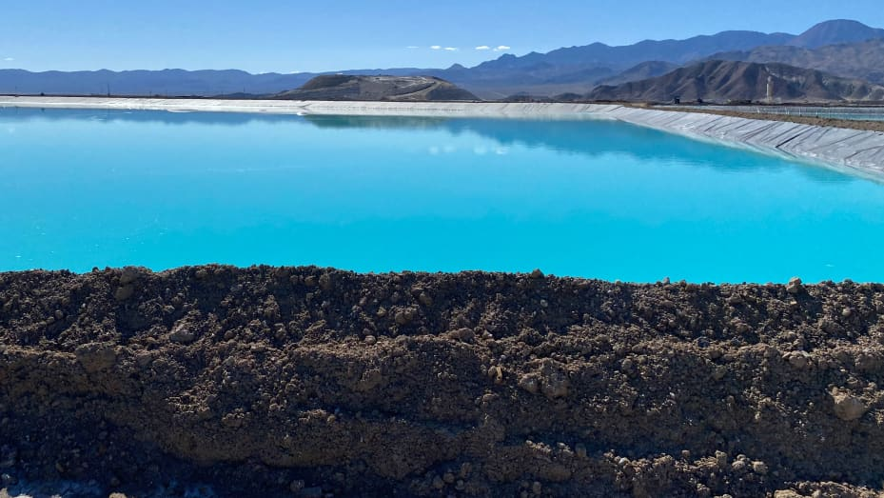

**One of the bright blue ponds at Albemarle’s lithium plant in Silver Peak, Nevada.**

Developing a domestic supply chain includes these 2 important stages in EV battery raw materials:

1. Mining and Extraction
2. Ore Processing and lithium oxide production

According to Scientific American, the USA alone would require around 360,000 tonnes of lithium by 2050 to meet its EV demands. This number although substantially high can be met through a planned domestic supply chain for raw materials such as lithium.

**The Solution:**

1. **Mining and Extraction of Lithium ore:**

The Silver Peak Lithium mine in Clayton Valley, Nevada, USA currently produces 5000 tonnes of LCE, and Albemarle’s plans to increase capacity to 10000 metric tonnes certainly have huge significance.

The angel in disguise is the Thacker Pass in Nevada, USA, which is estimated to hold a mineral amount of 13.7 million tonnes of LCE.

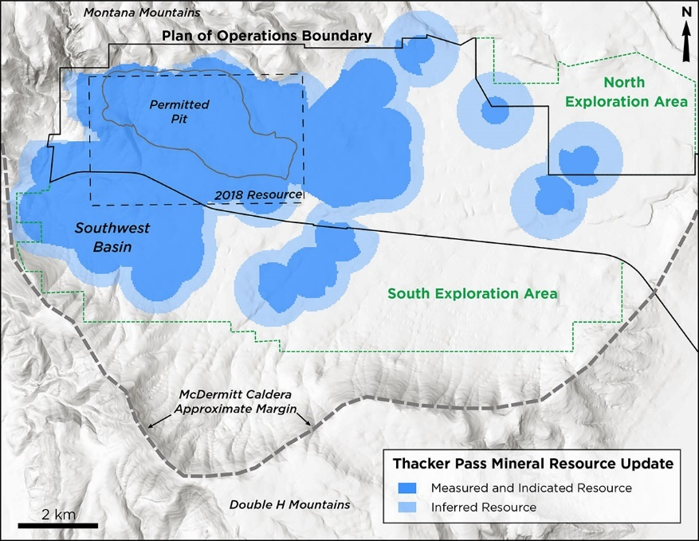

**Table 1: Updated Mineral Resource Estimate**

|  |  |  |
| --- | --- | --- |
| **Category** | **EFFECTIVE DATE OF OCTOBER 7, 2021** 1,334 PPM LI CUT-OFF GRADE | **EFFECTIVE DATE OF APRIL 5, 2018** 2,000 PPM LI CUT-OFF GRADE |
| Measured | 654.2 Mt 2,356 Average Li (ppm) 8.2 Mt LCE | 242.2 Mt 2,948 Average Li (ppm) 3.8 Mt LCE |
| Indicated | 499.4 Mt 2,067 Average Li (ppm) 5.5 Mt LCE | 143.1 Mt 2,864 Average Li (ppm) 2.2 Mt LCE |
| **Total Measured and Indicated** | **1,153.6 Mt 2,231 Average Li (ppm) 13.7 Mt LCE** | **385.3 Mt 2,917 Average Li (ppm) 6.0 Mt LCE** |
| Inferred | 391.6 Mt 2,112 Average Li (ppm) 4.4 Mt LCE | 147.4 Mt 2,932 Average Li (ppm) 2.3 Mt LCE |

[3]

Early phase I plans indicated the production of 35000 tonnes per annum (TPA) of LCE by Lithium Nevada, which is a subsidiary wholly owned by Lithium Americas and operates at Thacker Pass, Nevada.

**Incorporating Phase 2 to target an additional 40,000 TPA capacity.**A feasibility Study is being designed to incorporate a potential Phase 2 expansion scenario to target a total capacity of 80,000 TPA to meet potential partner and customer demand. The Company expects to provide an update on the timing of the Feasibility Study by early 2022 to align with the strategic partnership process and ongoing engineering work.

The Record of Decision (“ROD”) was received in January 2021 from the Bureau of Land Management (“BLM”). In February 2021, claims were filed against the BLM to appeal the issuance of the ROD. Injunction requests over the Company’s plan to begin pre-construction work were denied in Q3 2021. A court hearing on the appeal is expected to take place in February 2022, with the ruling to follow shortly thereafter.

**February 7, 2023 – Vancouver, Canada: Lithium Americas Corp. (TSX: LAC) (NYSE: LAC)**(“**Lithium Americas**”**or the**“**Company**”) received a favorable ruling from the US District Court, District of Nevada (“**Federal Court**”) on February 6, 2023, for the appeal filed against the Bureau of Land Management (“**BLM**”) for the issuance of the Record of Decision (“**ROD**”) relating to the Company’s 100%-owned Thacker Pass project (“**Thacker Pass**” or the “**Project**”) located in Humboldt Country, Nevada. The Federal Court has declined to vacate the ROD for the mining Plan of Operations (the “**Federal Permit**”). The favorable ruling by the Federal Court confirms the permitting process for Thacker Pass was conducted thoroughly and responsibly and resulted in there being no impediment to commencing construction. The Federal Court ordered the BLM to consider one issue under the mining law relating to the area designated for waste storage and tailings and did not impose any restrictions expected to impact the construction timeline.

“We are pleased that the Federal Court has recognized the BLM’s decision to issue the Federal Permit, reflecting our considerable efforts to ensure Thacker Pass is developed responsibly and for the benefit of all stakeholders,” said Jonathan Evans, President, and CEO. “The favorable ruling leaves in place the final regulatory approval needed in moving Thacker Pass into construction.” The Federal Court rejected arguments that the Project will cause unnecessary and undue degradation to the local sage grouse population and habitat, groundwater aquifers, and air quality; that the BLM failed to adequately assess the Project’s impacts on air quality, wildlife, and groundwater; that the BLM failed to adequately consider the Project’s impacts to culturally or religiously significant areas; and that BLM acted unreasonably or in bad faith in identifying tribes for consultation before approving the Project. The remand issued by Federal Court to the BLM is to determine whether the Company possesses adequate mining-claim rights to the lands over the area in which the waste storage and tailings are expected to be located, based on an appellate decision that was issued after the BLM issued its ROD for Thacker Pass. The Company intends to work closely with the BLM to complete the required follow-up [3].

This is a phenomenal addition to the domestication of the lithium supply chain. The operation of Thacker Pass in Nevada along with the Silver Peak Lithium Mine will produce around 100,000 TPA of LCE.

This is a great first step to the domestication of the Lithium supply chain. One of the other miners is Piedmont Lithium which operates at the Spodumene belt in North Carolina. Piedmont has already spent $58 million on the project, which would produce about 30,000 tonnes of lithium annually, enough to make about 3 million EVs in about 4 years. The company originally planned to put its chemical plant in a neighboring county, but now intends to build it near the mine, a step that should reduce truck traffic. Piedmont also plans to crush rock in the mine pit, alleviate dust, and incorporate solar power.

Piedmont’s deal with Tesla involves supplying roughly 53,000 tonnes of spodumene concentrate to the automaker’s planned lithium hydroxide chemical plant in Texas starting sometime between July 2022 and July 2023.

1. **Ore Processing and Lithium Oxide Production**

Lithium ore (LCE) extraction alone will not be enough as the extracted raw material has to be processed into the required chemical compound, in this case, into lithium oxide (Lithium Cobalt Oxide to be precise). Currently, North America processes and produces about 1000 tonnes, 1% of global lithium while China produces 79% of the global lithium [1]. Lithium Americas plans to mine and process LCE on-site at Thacker Pass.

What is the current tonnage of lithium processed in China, and how much tonnage is purchased by American companies from China?

If the USA starts processing lithium ore processing, how much tonnage will they be processing and how will it help lessen their reliance on China?

References

[1] United States Geological Survey

[2] Natural Resources Canada (NRCAN)

[3] Lithium Americas